Cabin in the wood


Text Adventure User Guide

Created by: Tianyi Chai, Yaxuan Xu, Zhiyuan Yu

Table of Contents

Background Introduction…………………………………….3
What is Text Adventure?
Game World
Plot Summary
How to Play this Game………………………………4
Play Guide
Commands List
Inventory Items
Hints and Advices
Troubleshooting…………………………………………………6
Error Messages
Puzzle Solving

Introduction

There is a definition from Wikipedia: Interactive fiction, often abbreviated IF, is software simulating environments in which players use text commands to control characters and influence the environment. In common usage, the term refers to text adventures, a type of adventure game where the entire interface can be "text-only", however, Graphical text adventure games, where the text is accompanied by graphics (still images, animations or video) still fall under the text adventure category if the main way to interact with the game is by typing text.

Cabin in the Wood is a text adventure that was designed by Tianyi Chai, Yaxuan Xu and Zhiyuan Yu. Like other interactive fiction, Cabin in the Wood has its own game world: a lonely, dangerous but also fantastic forest and closed cabin. Our character, Fisher, is locked in the cabin and he forgot why he is here. The main goal for Fisher is find out the way to escape from cabin and forest. Along the way, Fisher will encounter different trouble and danger. As our clever character, Fisher will discover some tools in various rooms and come up with some solution for challenge he meets.


For example, in the first room Fisher wakes up, the door is locked. Fisher may spend some time trying to find the key but this plan does not work successfully because there is no key in the room. Then, Fisher will change to search the table he sees and find a paper and a pen. The only thing he can do is trying to draw something and fantastic event happen: what he draw will appear in the presence of him. This leads Fisher to finally draw an axe in order to break the door and escape from the room successfully.

How to Play this Game?
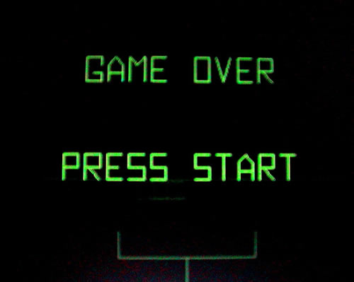
As a text adventure, you will input multiple words to execute different commands and check if character can get into new context or discover something new. Basically, you are recommended to try more commands when you get stun in some steps. For example, there may be no key in the room for you to unlock the door and you may try different method to achieve your goal. Whimsicality is very important when you play Cabin in the Wood.

Commands list:
Look: Fisher looks around to verify his context such as noticing door, table, and so on.

Open: Fisher tries to open something near him. This command can be used for open the door, storage, and so on if they are unlocked.

Pick: Fisher picks something up. This command will help him obtain the tool into his inventory.

Walk: Fisher walks to somewhere. This is a move command.

Eat: Fisher eat food in order to get benefit

Read: Fisher read something he gets and obtains useful information.

Attack: Fisher uses weapon to attack monster.

Inventory Items
Axe: Fisher can use axe to split door

Pen: Fisher can use pen to write and draw.

Paper: Fisher can use paper and pen to complete writing or drawing something.

Book: Fisher can use book to cast four spell with 2 buff and 2 debuff

Sausage: Fisher can eat sausage to obtain HP, limit into 3 times;
Knife: Fisher use to attack the monster;
Wood stick: Fisher can use it to escape from monster;
Wool: Fisher can get wool by defeating the monster sheep
Wool coat: It can help Fisher lower the damage taken form monsters;
Apple: use to give the girl in exchange of


Reasonable using the tools you get in the cabin and always trying different commands when you are confused will help you a lot. Remember, every tool has its own function and all tools are useful in specific step. Pick everything you find and do not miss any possible areas that contain something important. If you are a first time player or you are not familiar with such game, you may feel confused about everything. Summarize all information and hints you get during the game and restart the game if it is necessary. Trying more times will help you understand the key to play text adventure and once you become experienced, you will feel easier.

Troubleshooting

You will get error message if you input the wrong words or if you use incorrect commands in certain context. In that case, please double check your input and retype it. And there are some steps to help your puzzle solving when you encounter trouble in the game:
- Check if the game is executing well
- Check if the problem is program bug or not? If it is, report to us immediately.
- Check if you input the wrong words.
- Check if you use unreasonable commands.
- Rethink your current goal? (Open the door? Find a weapon?)
- Try various tools again.



